**Fight/Flight/Freeze**

Our bodies respond to stress as a threat and goes into a state call Fight/Flight/Freeze. This is like our body’s alarm system and helps us to survive, by preparing our body to fight, run away or freeze. Our bodies can feel funny due to the changes that are happening, but it cannot harm us! If you can remember what your physical stress response is, then it won’t feel as scary next time.

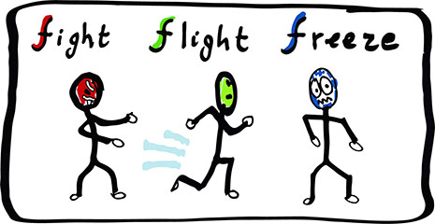

**Emotions**

It is normal to experience all kinds of emotions, such as anger, joy, sadness, fear and disgust. Sometimes when we are feeling one feeling more than others, then we might need some help.

It is always OK to talk about our feelings and to ask for help if we are struggling.



**Brain Freeze!**

When we are in the Fight/Flight/Freeze response, our brains shut down to the survival centre (or brain stem). This makes it harder for us to make sensible decisions, or to find the words to tell people how we feel. It is important to relax and calm our bodies down so we can stop the brain freeze and deal with the worry.



**Anxiety**

**Anxiety is another word for worry, everyone has worries sometimes, and we need a little bit of anxiety to help us perform well in tests or hobbies. But if we are experiencing too much anxiety, then we can become poorly.**

**Distraction**

**Another way of dealing with the Fight/Flight/Freeze response is to do something you enjoy, which will help you to focus on something other than your worries. Distracting ourselves is a good way to deal with worries about situations that we cannot change or control.** 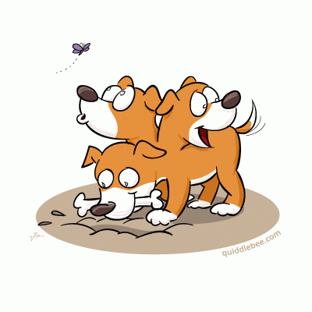

**Relax!**

**The best way to calm our bodies down and stop the brain freeze is to relax our body and mind. This will open up our thoughts and help us to deal with the worry in a calm way.**





**What do I worry about? ….**



**Can you think of 5 people that you can talk to about your worries?**

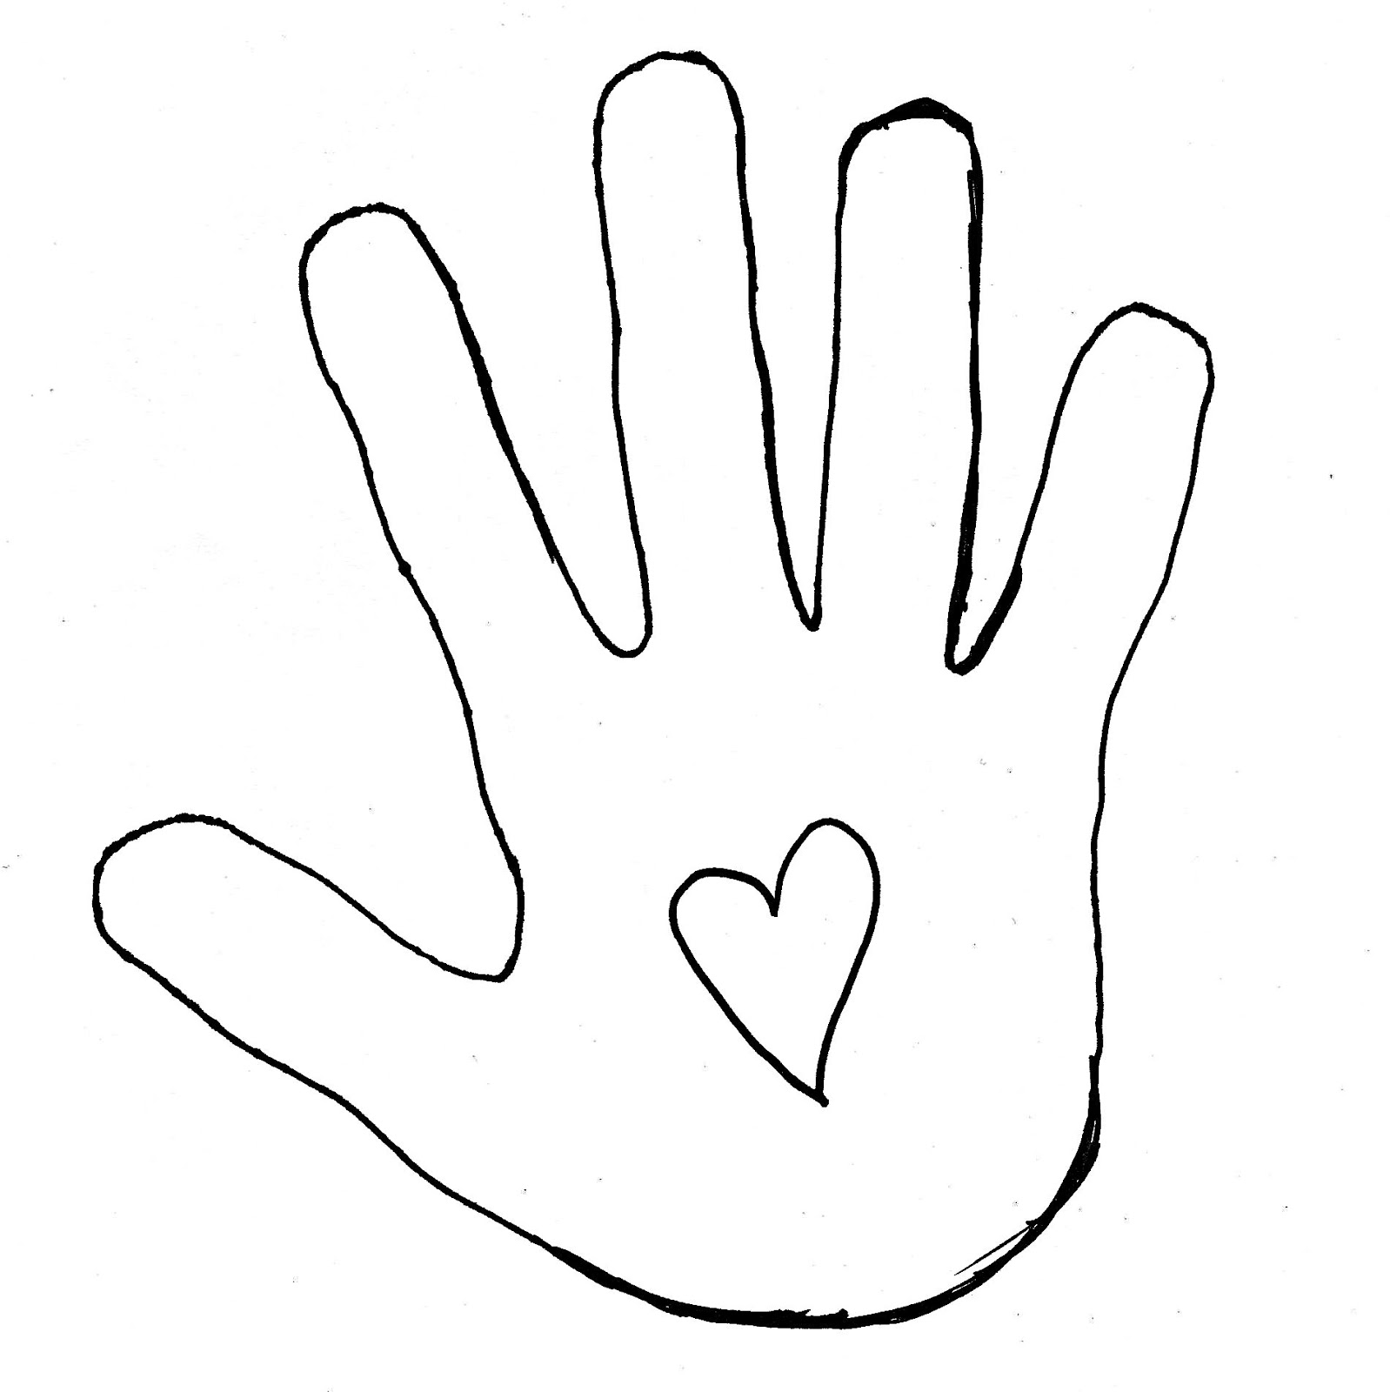

**What are my physical signs of anxiety?**

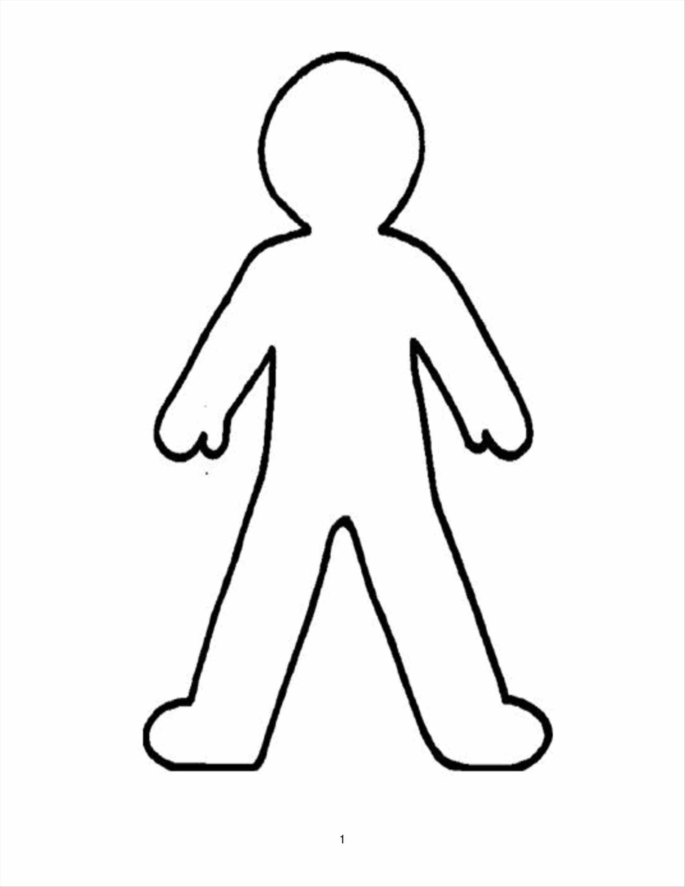

**Relaxation**

Breathing exercises are the best way of calming ourselves down when we are in our F/F/F response. This will calm down our body and brain and help us to think more clearly. Try this breathing exercise and think of another activity that makes you relax….

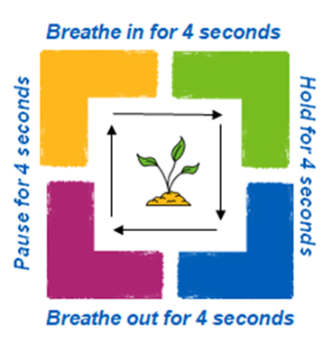

**Distractions**

**What helps to distract you when you’re feeling worried?**



**What am I going to do to look after myself today?**

