**Zones of Control**

When we are feeling anxious, it is important to check if we are worrying about something that we have control over. Quite often we worry about things that we cannot change, and because there is nothing we can do about it, the situation cannot be resolved in our heads, causing further anxiety. Next time you are worried about a situation, ask yourself is this something that I have control over? Is it worth spending time worrying over? If the answer is no, then that is the time to use the relaxation and distraction techniques we discussed in week one and then to look at what we can control and deal with that.

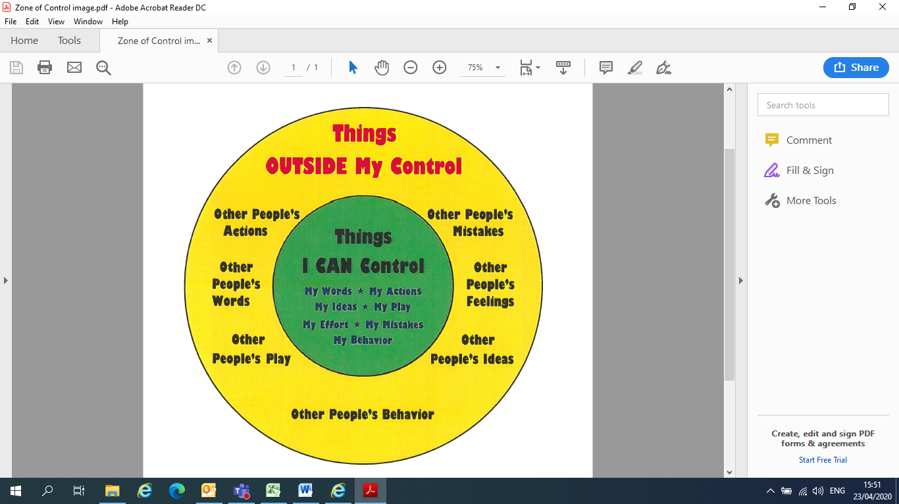

**Activity- Applying zones of controls- think of something that you worry about frequently. Using the diagram as a guide, have a think about what you can and can’t control in this situation. If you’re struggling, we’ve completed an example on the next page using a recent situation that has a lot of people worried. We’ve also included another helpful zone of control resource for you to use.**

Problem:

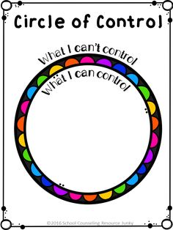

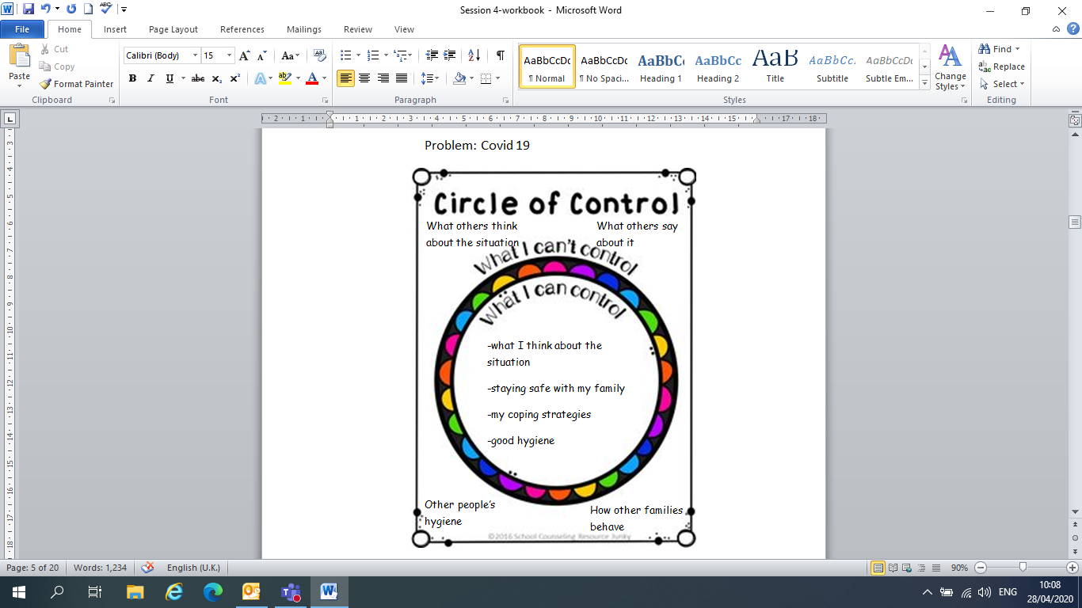**Example**

