30 hours free childcare

Working parents are able to receive up to 30 hours of free childcare
All 3 and 4 year olds receive 15 hours of 'universal' early education. An extra 15 hours of 'extended entitlement' are available to families where:
- Both parents are working (or the sole parent is working in a lone parent family);
- Each parent has a weekly minimum income equivalent to 16 hours at national minimum wage or living wage, equivalent to £125 per week for over 25s;
- Neither parent has an income of more than £100,000 per year.
Families where one parent does not work (or neither parent works) will not usually be eligible for the extended entitlement.
However the extended entitlement will be available where;
- Both parents are employed but one (or both parents) is temporarily away from the workplace on;
  - Parental, maternity or paternity leave
  - Adoption leave
  - Statutory sick pay
- One parent is employed and one parent has substantial caring responsibilities based on specific benefits received for caring
- One parent is employed and one parent is disabled or incapacitated based on receipt of specific benefits.

Am I eligible?
You can check your eligibility now by submitting an online application with Childcare Choices. Once signed up, you will receive an eligibility code to take to your childcare provider. Childcare providers will then check the code and agree a start date.
Once you have an eligibility code, you will need to reconfirm it every three months.
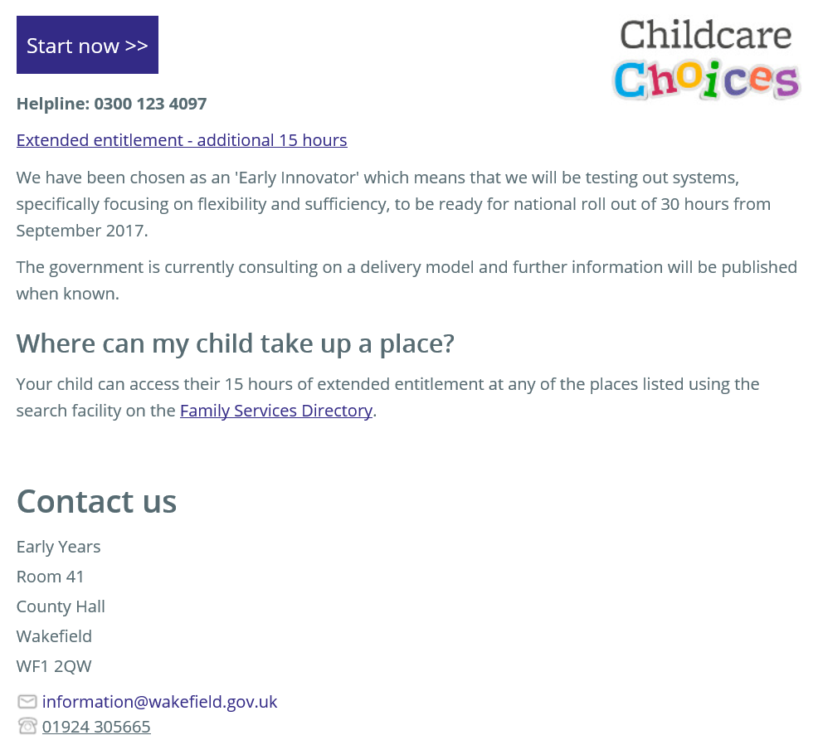
https://www.wakefield.gov.uk/schools-and-children/early-years-and-childcare/information-for-parents-and-carers/30-hours-free-childcare

