[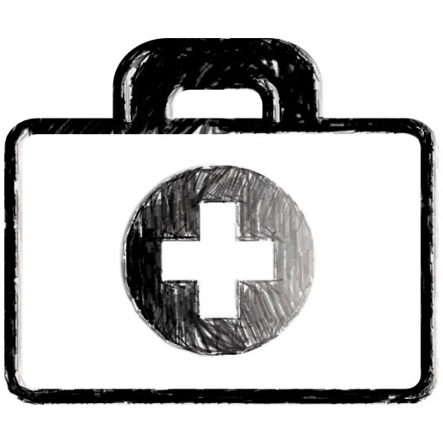](http://www.google.co.uk/url?sa=i&rct=j&q=first+aid+kit+clipart&source=images&cd=&cad=rja&docid=r8cOIsBt2ju6sM&tbnid=MbYW6D9nBmkfUM:&ved=0CAUQjRw&url=http://www.ipharmd.net/medical/firstaid_red_cross_clipart_169.html&ei=VccTUb2zIunD0QWaw4DYAw&bvm=bv.42080656,d.d2k&psig=AFQjCNGJg3Xmy1dRaWqWJQrgL0KA9fxpbg&ust=1360337080821126)[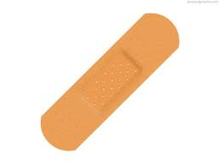](http://www.google.co.uk/imgres?q=plaster+clipart&start=133&hl=en&tbo=d&biw=1093&bih=514&tbm=isch&tbnid=CrdObHWJvxGPQM:&imgrefurl=http://www.picstopin.com/500/ribbons-psd-126-664-mb/http:||img43*imageshack*us|img43|4394|77632536*jpg/&docid=aeuKsJzOVm8o-M&imgurl=http://psdhunter.com/psds/6498-adhesive-plaster-icon-psd.jpg&w=610&h=458&ei=jSnnUJzZGO6R0QXHrYCoDg&zoom=1&iact=hc&vpx=457&vpy=177&dur=1549&hovh=194&hovw=259&tx=140.60003662109375&ty=111.80001831054687&sig=114199823161704333399&page=7&tbnh=139&tbnw=174&ndsp=29&ved=1t:429,r:51,s:100,i:157)[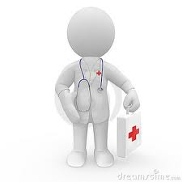](http://www.google.co.uk/imgres?q=first+aid+kit+stethoscope+clip+art&hl=en&tbo=d&biw=1093&bih=514&tbm=isch&tbnid=GgTDDsK_Ag4YuM:&imgrefurl=http://www.dreamstime.com/stock-images-doctor-stethoscope-first-aid-kit-image11283474&docid=4mjLZXEghGbdSM&imgurl=http://www.dreamstime.com/doctor-with-stethoscope-and-first-aid-kit-thumb11283474.jpg&w=400&h=400&ei=xirnUKTROOnD0QXbpoCwCw&zoom=1&iact=hc&vpx=2&vpy=63&dur=4621&hovh=225&hovw=225&tx=134&ty=126.60000610351562&sig=114199823161704333399&page=2&tbnh=145&tbnw=150&start=12&ndsp=18&ved=1t:429,r:18,s:0,i:140)[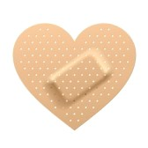](http://www.google.co.uk/url?sa=i&rct=j&q=first+aid+plaster+clipart&source=images&cd=&cad=rja&docid=8Lj_Un9rRI41DM&tbnid=ns7l0sIrploebM:&ved=0CAUQjRw&url=http://www.123rf.com/clipart-vector/band_aid.html&ei=nQURUeWMFYq60QWQ4IDQAg&bvm=bv.41867550,d.d2k&psig=AFQjCNGv9b9tGcw_DECE8HRaiq7eIDHcXg&ust=1360156426700580)[](http://www.google.co.uk/imgres?q=first+aid+kit+stethoscope+clip+art&hl=en&tbo=d&biw=1093&bih=514&tbm=isch&tbnid=GgTDDsK_Ag4YuM:&imgrefurl=http://www.dreamstime.com/stock-images-doctor-stethoscope-first-aid-kit-image11283474&docid=4mjLZXEghGbdSM&imgurl=http://www.dreamstime.com/doctor-with-stethoscope-and-first-aid-kit-thumb11283474.jpg&w=400&h=400&ei=xirnUKTROOnD0QXbpoCwCw&zoom=1&iact=hc&vpx=2&vpy=63&dur=4621&hovh=225&hovw=225&tx=134&ty=126.60000610351562&sig=114199823161704333399&page=2&tbnh=145&tbnw=150&start=12&ndsp=18&ved=1t:429,r:18,s:0,i:140)

# Mending Yourself

# Fill the ‘First Aid Kit’ with things that would help you feel better!

Your First Aid Kit

**What would you have in yours?**

# Our First Aid Kit

* A bubble bath
* A football game
* Flicking through a magazine
* Holding something that belonged to your special person
* Playing a computer game
* Talking to a friend
* Keeping a diary
* Writing
* Listening to music
* Reading and writing poems
* Reading
* Stroking your pet
* Painting
* Exercising/playing a sport
* Shopping
* Talking to an adult
* Playing in the park
* Growing things or gardening
* A bedtime story
* Being alone
* Praying
* Dancing
* Singing
* Looking at/talking to photos
* A cuddle
* Making a blanket from your special person’s clothes
* Doing some charity work in your lost person’s name
* Helping others
* Peer group support

**Emotional First Aid Kit**