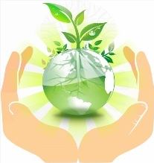
Kingfishers (Reception)
Spring 2 Topic:
Our Natural World

What are we learning this half term?
Understanding the World (Our Topic this half term) | Describe what they see, hear and feel in relation to living things.  Name and describe some plants.  Understand the effect of changing seasons on the natural world around them.
Maths  Free and premium Maths resources for teachers | White Rose Maths  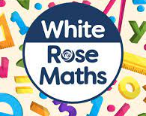 | 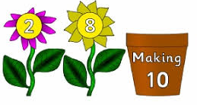  White Rose Maths  • Building 9 and 10  • 9 and 10  • Comparing numbers to 10  • Bonds to 10.  EYFS Framework  • Count beyond ten.  • Compare numbers- ‘more than’, ‘less than’, ‘fewer’, ‘the same as’, ‘equal to’  • Explore the composition of numbers to 10.  • Automatically recall number bonds for numbers 0–5 and some to 10
Literacy | Spell a range of words using single sounds and taught special friends. Write simple phrases with increasing confidence
Expressive Arts and Design | Use tools and techniques with increased care and precision.  Extend narratives within role play.  To mix a range of colours using a colour mixing chart.
Personal, Social and Emotional | Show resilience and perseverance in the face of challenge - develop problem-solving skills by talking through how they, you and others resolved a problem or difficulty.
Communication and Language | Use taught vocabulary with confidence when talking and playing
Physical Development | Form letters with increasing accuracy

Some of the key topic vocabulary we will be learning…
Spelling | Definition
living | Something that is alive and needs water to stay living
life cycle | Changes that a living thing goes through as it grows and develops
germinate | To start or cause growth
nutrients | Something in food that helps things live and grow

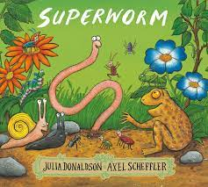
Some books we will read:
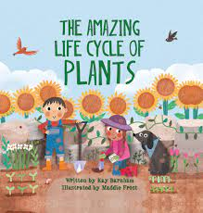
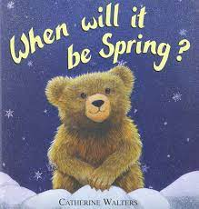
Spinderella,
Mad about Minibeasts
Superworm
When will it be Spring?
A Seed is Sleepy

How can you help at home?  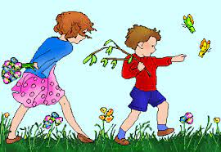 | - Go on a local walk and explore living things… what did you see/hear/smell/touch?  - Learn the names of different plants, flowers and trees – can you draw them or write a list?  - Watch documentaries about nature e.g. BBC Earth Kids
Please share any learning experiences with us on Tapestry.

Exciting Experiences!  Let’s explore seasonal changes… Spring enrichment week!  Monday 21st – Friday 25th March (week 4) | 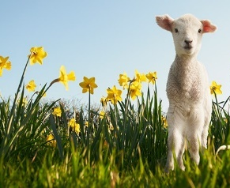
Plus… we will be hatching our very own chicks!

