**Set 2 reading at home**

ay ee igh ow

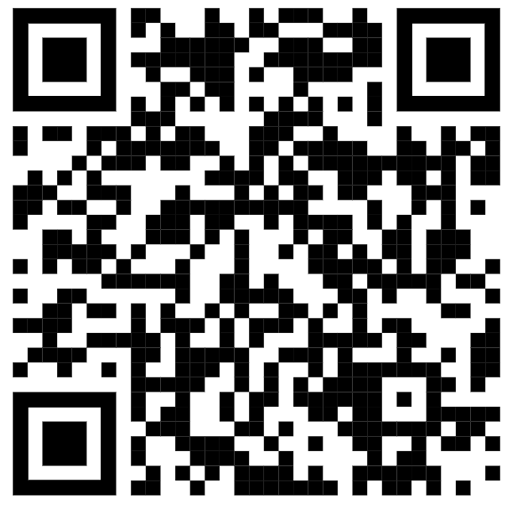

oo oo ar or

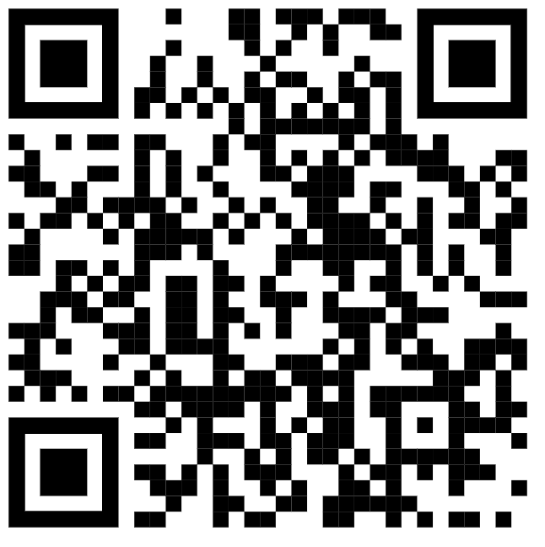

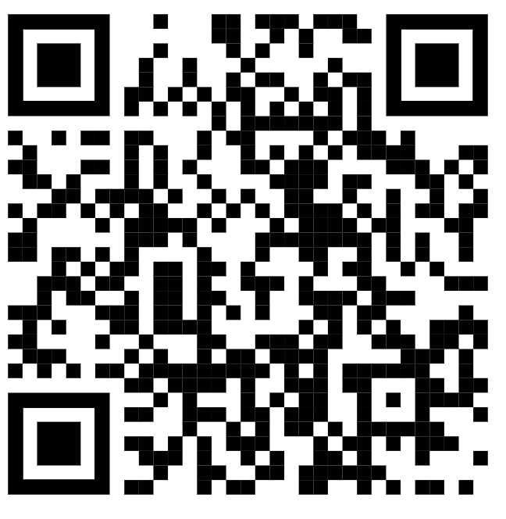

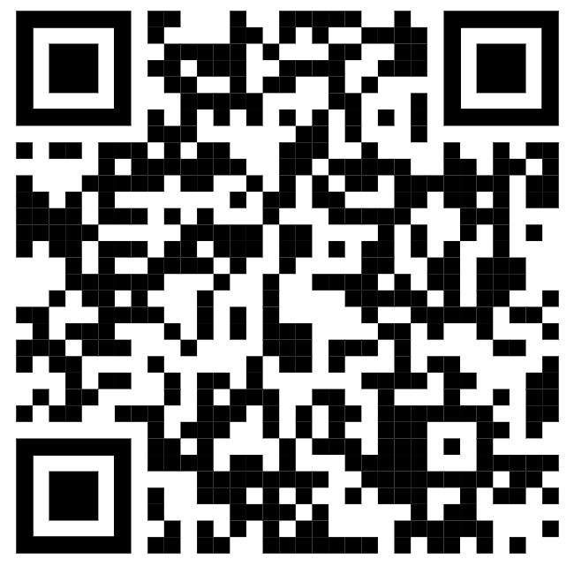

air ir ou oy

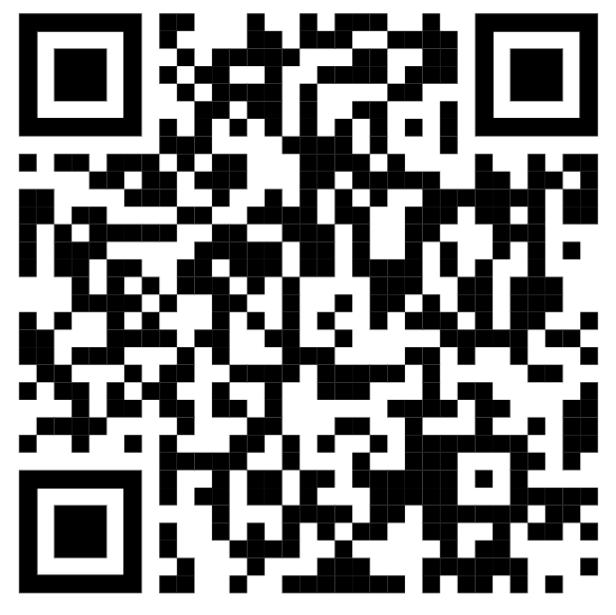

**Set 3 reading at home**

ea oi a-e i-e



o-e u-e aw are

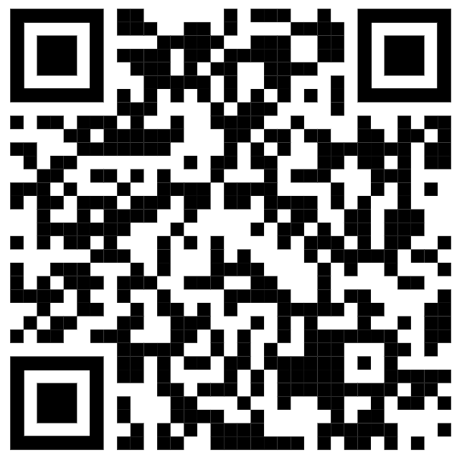

ur er ow ai

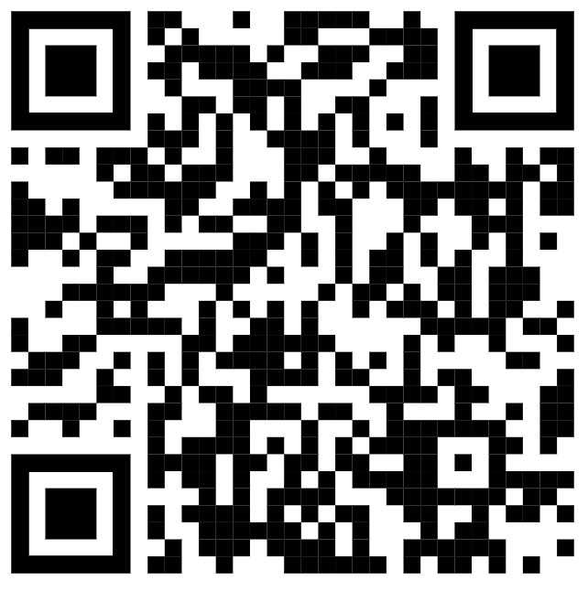



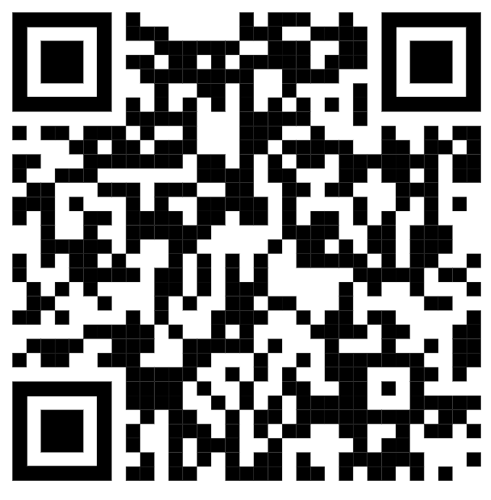

oa ew ire ear

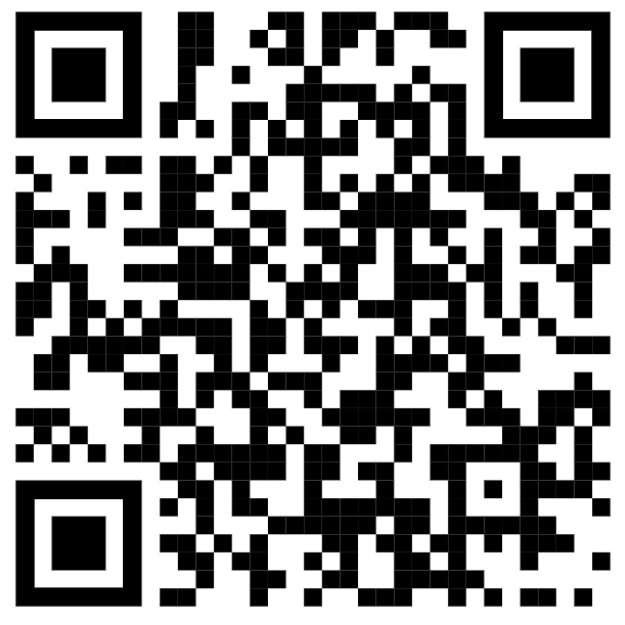

ure

